1. Start MySQL:
   1. Manually start server: START🡪SERVICES🡪MYSQL57
   2. **mysql -u root -p -h 127.0.0.1 -P 3306**

(Assumes no conflict with port 127.0.0.1)

1. Start local PM server (using shortcut on desktop screen):

**C:\XpressRules\Policy-Machine-master\apache-tomcat-8.5.23\bin\startup.sh**

1. Open PM app (as .jsp):

<http://localhost:8080/policy-machine-master/src/main/webapp/doc.jsp>

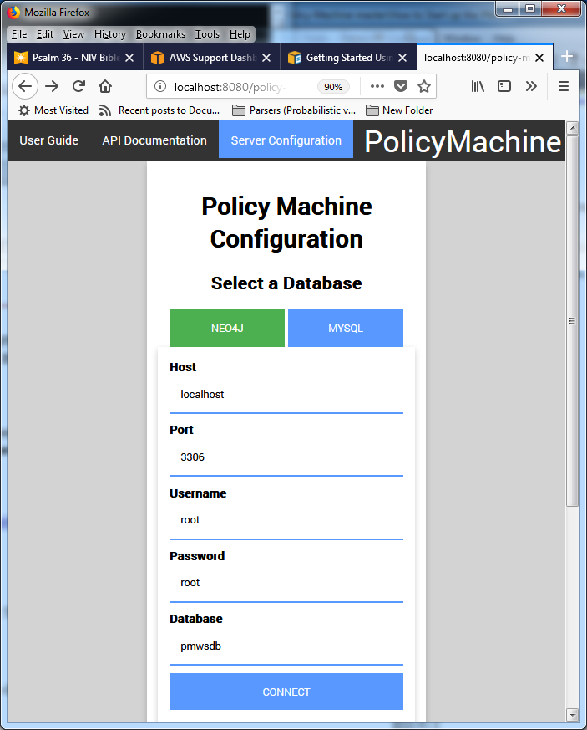

1. Neo4j of current display of NGAC sample:
   1. Start Neo4j Desktop on 3.3.0 Enterprise Bolt Server (mailAddr/storeAddr)
   2. Do NOT accept update 1.0.6!!!!!
   3. Start the Bolt server
   4. When RUNNING, click on “Open Browser”
   5. Under Saved Scripts: pick NGAC-ABAC Policy-01